**Model 1**

**Model 2**

**Model 3**

Model 4 (Removal of s1-3 & fix lag logic) – Model 2 equivalent

Model 5 (Removal of s1-3 & fix lag logic) – Model 3 equivalent

Model 6 (Inclusion of Team Rank Features)

Model 7 (Alter Rank col (numeric) & Home flag (factor))

Model 8 (Home Ground Advantage Interaction Terms)

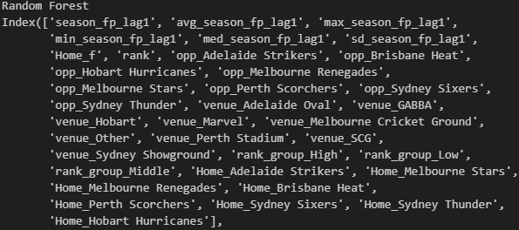

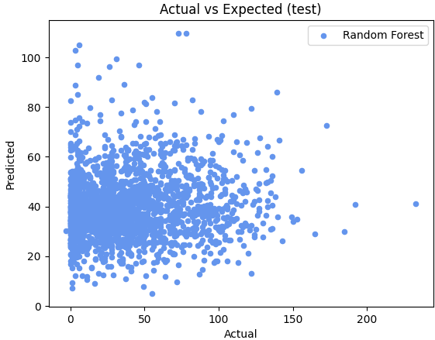

BBL 14 Bet365 Data

Pre Tournament

After Round 1 & Round 2

After Round 3 & 4

After Round 5 & 6

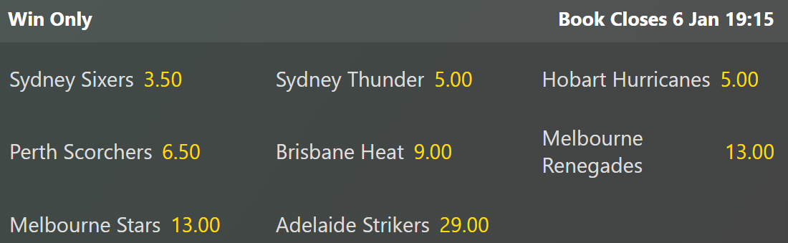

After Round 7 & 8

Model 9 (Which overs bowled)

Model 10 – Remove home team indicators

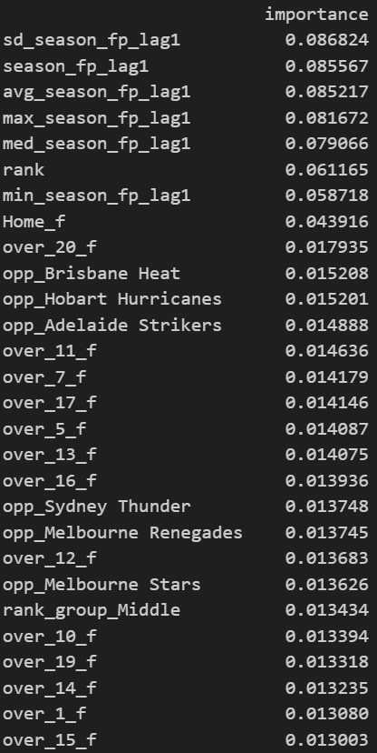

Model 11 – Incl/ During Tournament Features

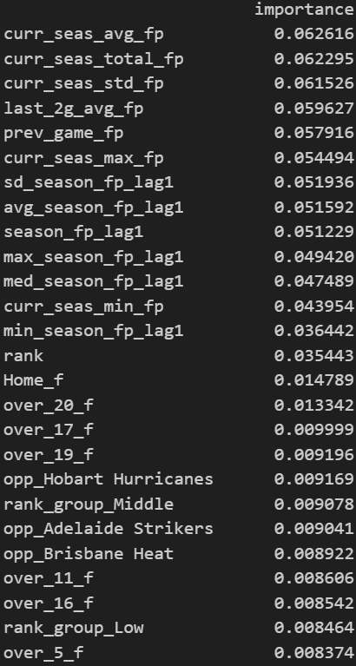

Model 12 – Post Power Surge Data

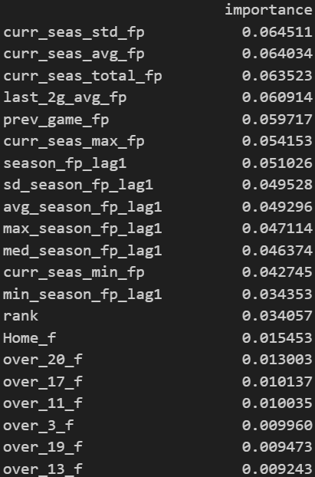

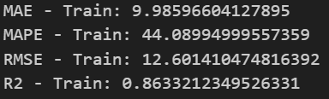

Model 13 – Batting Position Flags

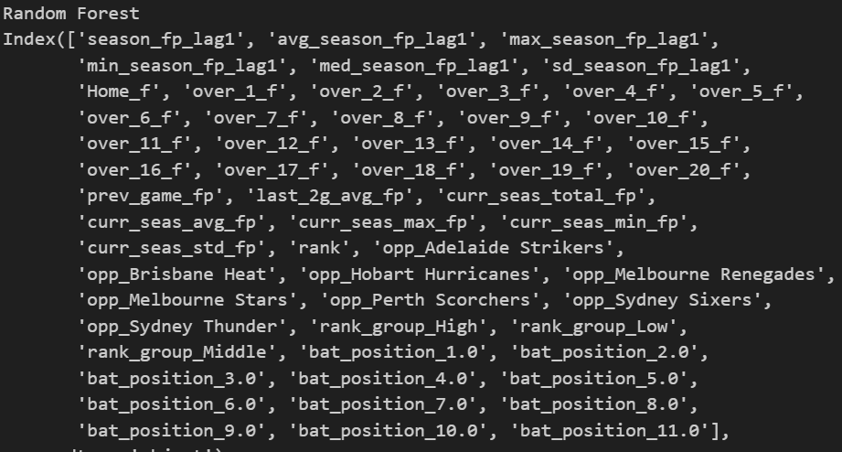

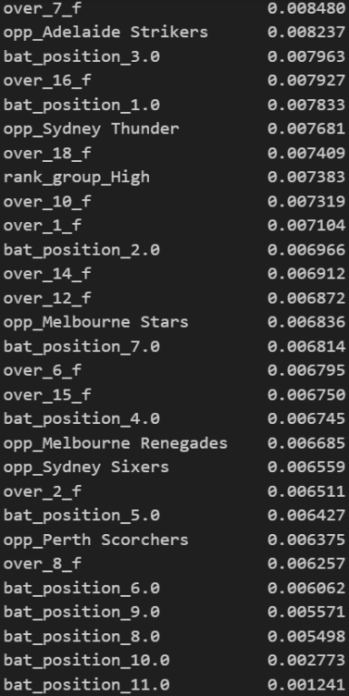

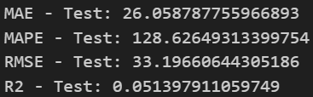

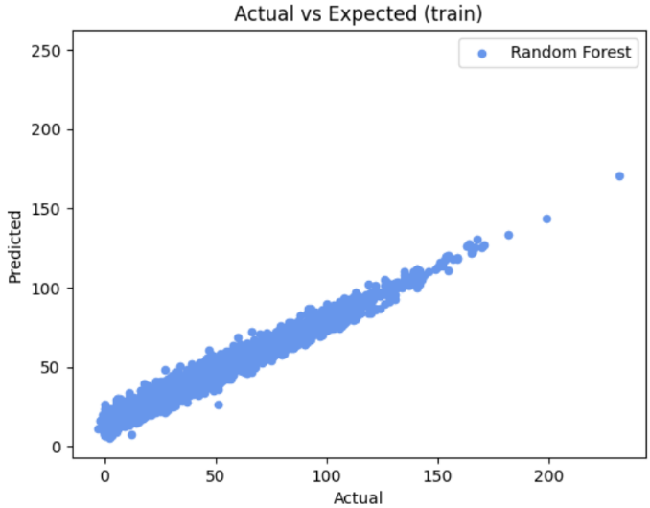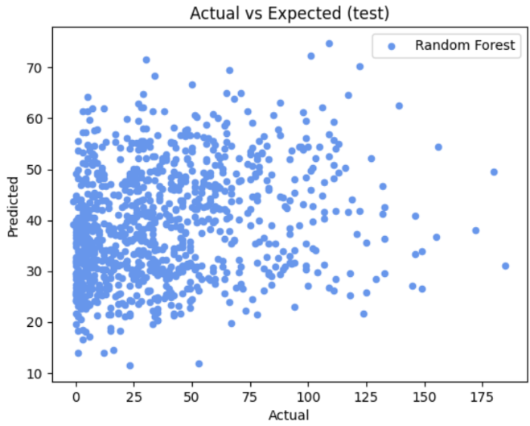

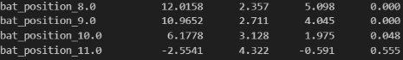

Model 15 - Round 4 w/ 3g average feature

Model 16 – w/o previous season stats

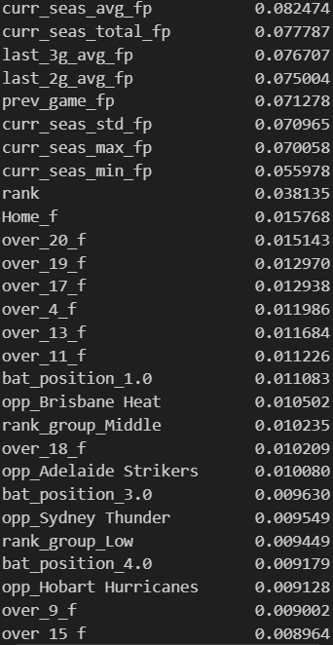

Model 17 – remove low importance features

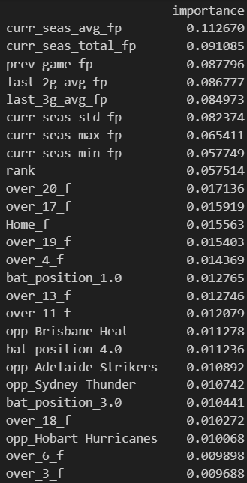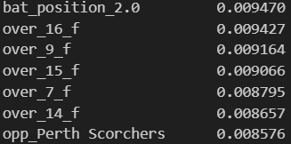

Model 18 – Add back over features

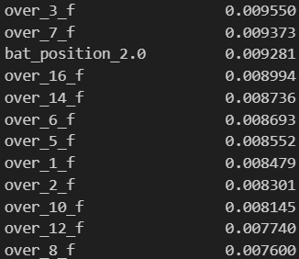

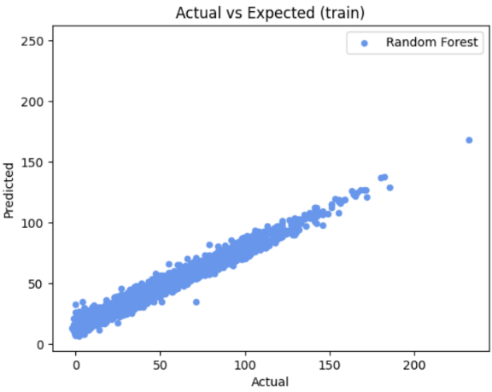

Next Season Improvements

1. Power Surge
2. Expected Bowling & Batting Fantasy Points (Split for better feature interactions)
3. Previous Total Runs, Total Wickets & Economy etc
4. Pricing Model
5. Full Season Trade Optimisation
   1. What is the best number of rounds to optimise
   2. Trade Boost
   3. Consider Captaincy & VC during optimisation and clearly define who to select for each
6. Deal with first game player introductions (peps who join late)
   1. 2g & 3g avg should be handled to understand it requires at least that many games
7. How to deal with international & new players to the tournament for pre tourney model
8. How to do bench tricks and select optimal bench (leverage 17 players not just 12)
9. Properly use batting order and bowling overs (use previous game ratios not during actual game)